1. Register

Route : http://localhost/dress_marketplace/api/register

Method : POST

Body :

* email : text
* password : text
* full_name : text
* gender : ‘M’ atau ‘F’
* phone_number : text

Kemungkinan output:

* 'status'=>false,'message'=>'Email already exist'
* 'status'=>true,'message'=>'User created successfully'

1. Login

Route : http://localhost/dress_marketplace/api/login

Method : POST

Body :

* email : text
* password : text

Kemungkinan output:

* 'status'=>false,'message'=>'User Not Found'
* 'status'=>false,'message'=>'User Non-Active'
* 'status'=>false,'message'=>'Invalid Credentials'
* 'status'=>true,'jwt'=>xxxxxxxxxxxxxxxxxxx

1. Get Auth User

Route : http://localhost/dress_marketplace/api/get_auth_user

Method : POST

Body :

* token : text

output:

* 'error'=>’blabla’ (statuscode 500)
* 'status'=>true, 'result'=>blabla

**Jalankan 3 perintah ini dulu :**

composer install

php artisan migrate

php artisan db:seed

1. Check Store Name

Route : http://localhost/dress_marketplace/api/check_store_name

Method : POST

Body :

* store_name : text

output:

* ‘status’ => true, ‘message’ => ‘Store Name Available’
* ‘status’ => false, ‘message’ => ‘Store Name Already Exists’

1. Register Store Name

Route : http://localhost/dress_marketplace/api/register_store_name

Method : POST

Body :

* token : text
* store_name : text

output:

* ‘status’ => false, ‘message’ => ‘Store Name Already Exists’
* ‘status’ => false, ‘message’ => ‘You already have store’
* 'error'=>'something went wrong, try again later'
* ‘status’ => true, ‘message’ => ‘Store Name registered Successfully’

1. Get Province List

Route : http://localhost/dress_marketplace/api/get_province_list

Method : POST

Body :

output:

* ‘province’ => data

1. Get City by Province

Route : http://localhost/dress_marketplace/api/get_city_by_province

Method : POST

Body :

* province_id : text

output:

* ‘city’ => data

1. Get Courier List

Route : http://localhost/dress_marketplace/api/get_courier_list

Method : POST

Body :

output:

* ‘courier’ => data

1. Register Store

Route : http://localhost/dress_marketplace/api//register_store

Method : POST

Body :

* token : text
* store_name : text
* photo : file (boleh null)
* banner : file (boleh null)
* description : text
* established_year : text
* province : text => berupa id yang didapat dari get province diatas
* city : text => berupa id yang didapat dari get city diatas
* business_type : text
* contact_person_name : text (boleh null)
* contact_person_job_title : text (boleh null)
* contact_person_phone_number : text (boleh null)
* courier : text => berupa array berisi id yang didapat dari get courier list
* ktp : file (boleh null)
* siup : file (boleh null)
* npwp : file (boleh null)
* skdp : file (boleh null)
* tdp : file (boleh null)

output:

* ‘status’ => false, ‘message’ => ‘You don’t have privilege’
* ‘status’ => false, ‘message’ => ‘error : blabla’
* ‘status’ => true, ‘message’ => ‘Store registered successfully’

Jalankan perintah ini:

php artisan migrate

php artisan db:seed --class=DressAttributeSeeder

1. Get Dress Attributes

Route : http://localhost/dress_marketplace/api/get_dress_attributes

Method : POST

Body :

output:

* 'style' : [],
* 'price' : [],
* 'size' : [],
* 'season' : [],
* 'neckline' : [],
* 'sleevelength' : [],
* 'waiseline': [],
* 'material': [],
* 'fabrictype': [],
* 'decoration': [],
* 'patterntype': []

Yang login tambah 1 response :

* 'status'=>false,'message'=>'User Non-Active'

1. Get User Store

Route : http://localhost/dress_marketplace/api/get_user_store

Method : POST

Body :

* token

output:

* ‘have_store’=> false, ‘store’ => null
* ‘have_store’=> true, ‘store’ => ~~~

Yang Register Store sudah direvisi, couriernya menjadi multiple

* courier : text => berupa array berisi id yang didapat dari get courier list

**contoh :**

courier[0] : 1

courier[1] : 2

1. Add Product

Route : http://localhost/dress_marketplace/api/add_product

Method : POST

Body :

* Token : text
* Name : text (nama barang)
* Min_order : text
* Weight : text (dalam satuan gram)
* Description : text
* Style_id : text
* Season_id : text
* neckline_id : text
* sleevelength_id : text
* waiseline_id : text
* material_id : text
* fabrictype_id : text
* decoration_id : text
* patterntype_id : text
* size[] : text -> berupa array yang berisi id size
* price[] : text-> berupa array yang berisi informasi qty_min, qty_max, price
* photo : file

Yang price contohnya gini :

0 – 10 harganya 100000

11-20 harganya 90000

>21 harganya 80000

Jadi tulisnya gini :

Price[0][qty_min] = 0

Price[0][qty_max] = 10

Price[0][qty_price] = 100000

Price[1][qty_min] = 11

Price[1][qty_max] = 20

Price[1][qty_price] = 90000

Price[2][qty_min] = 21

Price[2][qty_max] = max

Price[2][qty_price] = 80000

**Contoh**

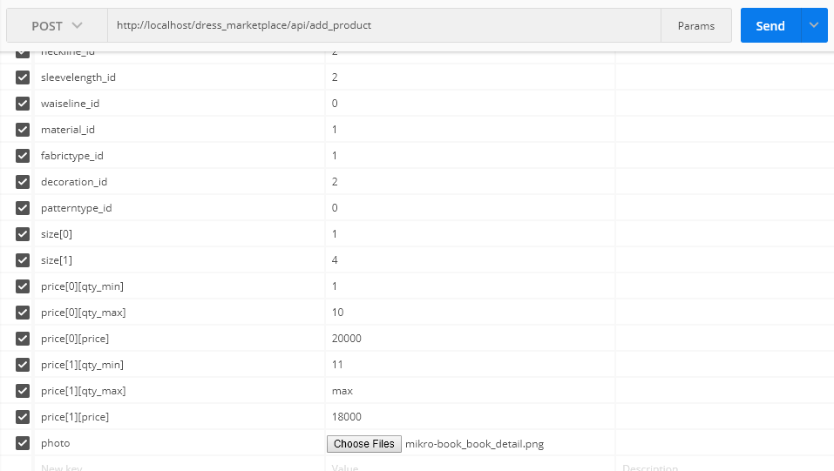

output:

* ‘status=> false, ‘message’ => ‘You don’t have privilege’
* ‘status=> false, ‘message’ => ‘error’
* ‘status=> true, ‘message’ => ‘Product Registered Successfully’

Kalau mau lebih jelas coba liat yang versi Web : <http://localhost/dress_marketplace/seller_panel_product>